

CSCE4930-01

FSM simulator User's Guide

Mohamed Ashraf Taha

ID: 900172754

Submitted to:

Dr. Sherif El-Kassas

Eng. Mahmoud Esmat

5/12/2021

User Guide for my FSM simulator:

1. *Compilation****: N.B: added -pthread argument***

Method 1:

**make**

Method 2:

**g++ -pthread -std=c++11 -ggdb -fno-elide-constructors -o MFSMtest *.cpp**

***II.*** *Run:*

**./MFSMtest testfiles/mFsm#N.mfsm**

**, where #N is the number of the mfsm machine in words, i.e: One,Two,Three,etc ...**

**In my case (as an example):**

**./MFSMtest testfiles/mFsmOne.fsm**

***III.*** *How to use the Simulator*

* 1. ***Theoratically***

1. First step is to create your FSMs each FSM has the its number “In words” ,i.e FsmOne, FsmTwo, etc..
2. In each FSM, First start by defining the MFsm Machine name, Variables, states, required actions, and transitions.
3. The machine name will be the same as the file name
4. Initially all the variables are set to 0
5. Then the first state in the file will be the initial state to start the machine
6. Then the user will be prompted to enter the next transition and according to the transition lines stated in the file.
7. There is also error reporting in the run if the user entered a transition that does not exist for a certain state.
8. For the MFSM, start by creating a file with prefix mFsm and the mfsm number in words, i.e, mFsmOne, mFsmTwo, mFsmThree, etc.. .
9. Then define a section called “COMVAR” this section will contain the common variable (global variables) to be shared between all FSMs.
10. Then Define a section called “Machines” having the list of the FSM machines on separate lines.
11. Below is a screenshot of how the mFsm file should look like:

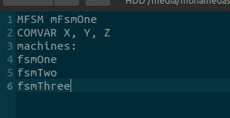

B. **Practically: (this section contains two methods of running and visualizing the output):**

1.Terminal outputs:

- Just run the machine and follow the instructions

2. Using the Tail Command which requires outputting to files and tracking the changes that happen to the files as the machines are running:

**-** *Steps to use this method:*

1. navigate to the outputFiles folder in the submission folder: cd testfiles/outputFiles
2. After running the machines open #N number of terminals, where #N is the number of machines in the mfsm file.
3. For example if we have three FSM machines in the MFSM file, we need to open three terminals. And run the command tail -F OUTfsm#N, where #N is the number of the machine in words.

*Commands (examle of three machines):*

1. *After running the mfsm*
2. *cd testfiles/outputFiles*
3. open three terminals:

A. Terminal1 : tail -F OUTfsmOne.fsm

B. Terminal2 : tail -F OUTfsmTwo.fsm

*C. Terminal3 : tail -F OUTfsmThree.fsm*

1. Below are screenshots of the output:

Note: Method 2 also supports method 1, method 1 is always used.

A. Method 1:

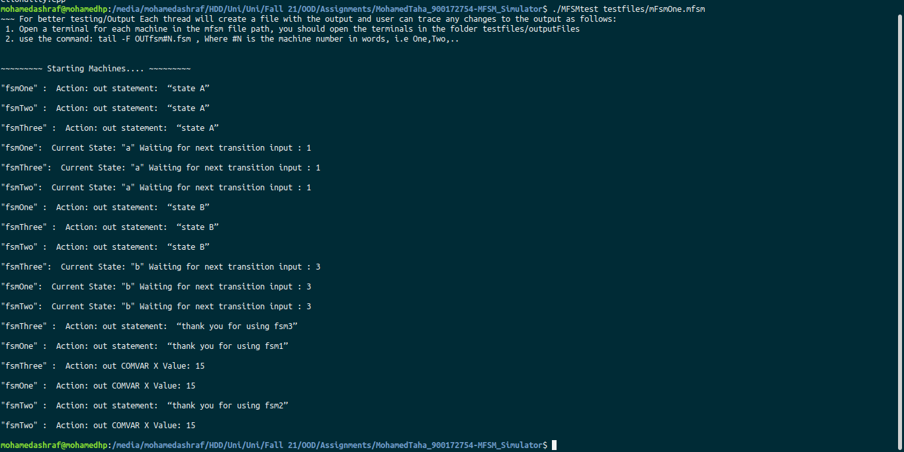

B. Method 2:

